Ministry of Education and Science of Ukraine
Yaroslav Mudryi National Law University, Ukraine
G.S. Skovoroda Institute of Philosophy NAS of Ukraine
Drahomanov National Pedagogical University, Ukraine
Institute of Philosophy, Political Science and Religious Studies,
KN MES Republic of Kazakhstan
Ivane Javakhishvili Tbilisi State University, Georgia

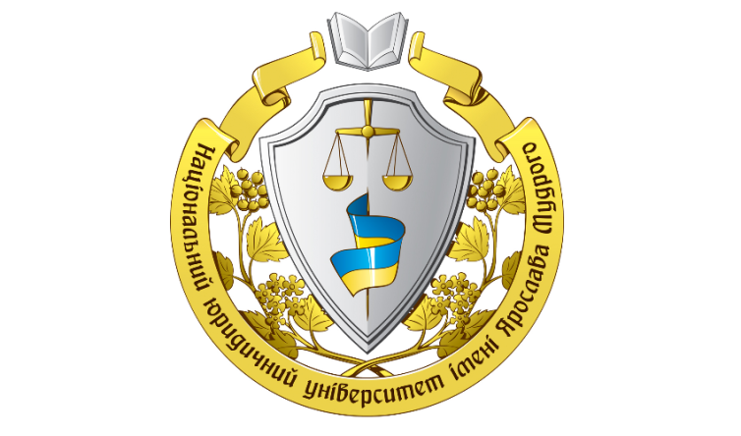

The ІІ International Scientific and Practical Conference

« Problems of personality self-development
in the modern society»

26 March, 2021

Kharkiv, Ukraine

Dear collegues!
We invite the scientific and pedagogical staff of native and foreign higher education institutes, young scientists, postgraduate students, students to take part in the International Scientific and Practical Conference «Problems of personality self-development in the modern society », which take place on 26th of March, 2021 in science library building of Yaroslav Mudryi.
National Law University by the address: Kharkiv, Pushkinska Street 84 А, 9th floor.

Participant registration : 10.00 - 10.45
Start of the Conference : 11. 00

The main areas of the conference:
1. Self-development of personality as a philosophical problem of the XXI century.
2. Self-development of personality: projection from humanism to transhumanism.
3. The problem of preservation of human personality in an information society.
4. Self-development and destruction of personality in the Postmodern era: boundaries and limitlessness.
5. Problems of personality self-development in religious anthropology.
6. Self-development of personality as a subject of modern psychological research.
7. Personal self-development in the system of education: traditions and innovations.

Conference languages: Ukrainian, English and Russian.

Organizing committee:
Getman A., rector Yaroslav Mudryi National Law University, Member of the National Academy of Legal Sciences of Ukraine, Doctor of Legal Sciences, Professor, Honored Man of Science and Technology of Ukraine
Rector
Ramishvili V., Doctor of Philosophy, professor head of department of Theoretical philosophy, Ivane Javakhishvili Tbilisi State University, Georgia
Seidumanov S., Doctor of Sociological Sciences, Professor, academician of the National Academy of Sciences of the Republic of Kazakhstan, acting Director of the Institute for Philosophy, Political Science and Religious Studies CS MES RK;
Khamitov N., Doctor of Philosophy, Professor, Leading Researcher in G.S. Skovoroda Institute of Phylosophy NAS of Ukraine President of the Association of Philosophical Arts
Krylova S., Doctor of Philosophy, Professor, Head of Cultural sciences and Philosophical anthropology department National Pedagogical Dragomanov University, Vice-President of the Association of Philosophical Arts
Lozovoi V., Doctor of Philosophy, professor, professor of culturology of Ukraine Yaroslav Mudryi National Law University
Pankov G., Doctor of Philosophy, professor, professor of culturology of Kharkiv State Academy of Culture;
Toktarbekova L., PhD, Chief Scientific Secretary of the Institute for Philosophy, Political Science and Religious Studies CS MES RK;
Melihova J., Candidate of Juridical Sciences, associate professor of culturology department of Ukraine Yaroslav Mudryi National Law University.
Scientific supervisor of the conference project
Shumeiko O., Candidate of Philological Sciences, associate professor, associate professor of culturology department of Ukraine Yaroslav Mudryi National Law University.
Scientific director of the conference project: Sidak L., Candidate of Philosophy Sciences, associate professor, associate professor of culturology department of Ukraine Yaroslav Mudryi National Law University.

All participants will have a program of the Conference, a theses compilation of the Conference reports and certificate.
Publishing of a compilation is planned before conference starts, meanwhile postal sending of printed theses compilation and participant’s certificate – after the Conference closes until 15st of April, 2021.

Forms of participation in the Conference: daily/distance.
Individual participation Doctors of Science and representatives of other countries is free.
Travel and accommodation are paid by participants’ costs. Hotel accommodation will be organized by the organizing committee influence.

In order to take part in Conference please send until 15th of March 2021to the email address rozvitok.conf@ukr.net the following:

– application for participation in Conference (example is added);
– electronic version of theses (2-5 pages, in *.doc format);
– electronic receipt about organization fee payment.
The name of the files must be signed like this: Batuk О.P._ Theses; Batuk О.P._B Receipt; Batuk О.P._ Application .

Example of application:
Application
to take part in the International scientific and practical conference «Problems of personal development in the modern society», which takes place on
26th of March, 2021

1. Full name_____________
2. Place of job or study (full name of organization)___________________________
3. Job position__________________________
4. Scientific degree ____________________
5. Area of the conference__________________
6. Theme of the report____________________
7. Email address ____________________
8. Phone number________________________.
10. Forms of participation ____________________________________________

Reqirements for theses the reports documentation:

Up to 5 pages, no numeration is needed, А4 format page, portrait orientation.
Page margins: upper, lower, left and right – 2 cm.
Font – Times New Roman 14, line spacing – 1.5 cm, indentation – 1.25 cm. Alignment justified. An author is responsible for the context.

Example of theses the reports documentation:

О.P. Batuk,
PhD, associate professor, associate professor
of culture theory and philosophy science
Кarazin Kharkiv National University

modern consept of personal development

Text

List of used literature:
1. Vlasova Е.А. History of Problems of personal development, Kharkiv Pholio, 2007, 232 p.

Sending information will be taken if the email confirmation is sent from organizing committee on your e-mail.

Conference organizer:
Culturology department of Ukraine Yaroslav Mudryi National Law University
Address: Pushkinska Street 84 А, Kharkiv, Ukraine, 61024

Contact:
Email address: rozvitok.conf@ukr.net
Phone numbers: +38 066 191 07 93, +38 097 637 55 76 (Sidak Ludmila)

